Department of Computer Science / Information Technology
SOFTWARE ENGINEERING
Case Study Analysis Report
Case Study 34 – SDG 4: accessible learning platform
Student Name | [B. Pushparaj]
Register Number | [192421136]
Class & Section | [CSA1008-Software Engineering]
Faculty Name | [K. C. Sharmili]
Date of Submission | [24.07.2026]

Table of Contents
1. Introduction 3
2. Problem Understanding 4
3. Stakeholder Analysis 5
4. Existing System Analysis 6
5. Proposed Software Solution 7
6. System Design 10
7. Methodology / SDLC Selection 13
8. Implementation Plan 14
9. Expected Outcomes 15
10. Risks and Limitations 16
11. Future Enhancements 16
12. Conclusion 17
13. References 17

1. Introduction
1.1 Background of the Problem
Education is a fundamental right for every individual. With the rapid growth of digital learning, educational institutions increasingly rely on online learning platforms to deliver lectures, assignments, quizzes, and study materials. However, many of these platforms are designed primarily for sighted users and do not fully support students with visual impairments. Features such as inaccessible navigation, images without descriptions, poorly structured content, and inaccessible online assessments create barriers to learning. As a result, visually impaired students often struggle to participate independently in online education.
An accessible learning platform can overcome these challenges by integrating assistive technologies such as screen reader compatibility, voice navigation, text-to-speech, audio learning resources, keyboard navigation, and accessible assessments. Such a platform ensures equal learning opportunities for all students.

1.2 Importance of Solving the Problem
Developing an accessible learning platform is important because it:
- Promotes equal educational opportunities.
- Supports independent learning.
- Improves accessibility for visually impaired students.
- Reduces educational inequality.
- Enhances student engagement and academic performance.
- Encourages inclusive education.

1.3 Related SDG Goal
United Nations Sustainable Development Goal 4 – Quality Education
Goal:
Ensure inclusive and equitable quality education and promote lifelong learning opportunities for all.
This project contributes by providing equal digital learning access for visually impaired students.
1.4 Objectives of the Case Study
The objectives are:
- Develop an accessible online learning platform.
- Support screen readers and voice navigation.
- Provide audio-based educational resources.
- Enable accessible online assessments.
- Improve learning independence.
- Promote inclusive education.

2. Problem Understanding
2.1 Problem Description
Students with visual impairments face many challenges when using traditional online learning systems. Most educational websites are designed mainly for users who can see visual content. Navigation menus are difficult to access using keyboards or screen readers, learning materials are mostly text or images without audio alternatives, and online assessments are often inaccessible. These limitations reduce learning efficiency and create inequality in education. Therefore, there is a need for an accessible digital learning platform that supports assistive technologies and provides equal educational opportunities.

2.2 Objectives
- Reduce learning barriers.
- Improve accessibility.
- Support screen readers.
- Enable voice-based navigation.
- Improve learning efficiency.
- Increase student engagement.
- Provide accessible assessments.
- Promote inclusive education.

2.3 Scope
In Scope
- Student registration and login.
- Screen reader compatibility.
- Voice navigation.
- Audio learning materials.
- Online quizzes.
- Assignment submission.
- Teacher dashboard.
- Student progress reports.
Out of Scope
- Offline learning.
- Video editing.
- Payment gateway.
- Library management.
- Hostel management.
- Campus administration.

3. Stakeholder Analysis
Stakeholder | Role
Administrator | Manage users and platform settings
Student | Access learning materials and assessments
Teacher | Upload study materials and evaluate students
Institution | Monitor academic activities
Technical Support | Maintain the software system
Government | Ensure accessibility standards compliance
Parents | Monitor student progress

4. Existing System Analysis
4.1 Existing Process
Most online learning systems provide digital classrooms, assignments, quizzes, and communication tools. However, accessibility features are limited. Many systems depend heavily on visual interfaces, making navigation difficult for visually impaired users.

4.2 Strengths
- Online learning anytime.
- Digital study materials.
- Easy assignment submission.
- Faster communication.
- Centralized information.

4.3 Weaknesses
- Limited accessibility support.
- Poor screen reader compatibility.
- Difficult keyboard navigation.
- Visual-only learning materials.
- Inaccessible online assessments.
- Lack of voice interaction.

4.4 Gap Analysis
Current systems fail to provide complete accessibility for visually impaired students. They lack voice navigation, accessible assessments, audio learning materials, and proper assistive technology integration.

5. Proposed Software Solution
5.1 Proposed System
The proposed system is an Accessible Learning Platform designed specifically for students with visual impairments. It integrates screen reader support, text-to-speech technology, voice navigation, keyboard shortcuts, audio learning materials, and accessible online assessments. Teachers can upload accessible content while students can independently access educational resources using assistive technologies.

5.2 Functional Modules
- User Registration
- Login
- Student Dashboard
- Teacher Dashboard
- Audio Learning Resources
- Voice Navigation
- Accessible Assessments
- Progress Tracking
- Notifications
- Admin Panel
5.3 Functional Requirements
ID | Functional Requirement
FR1 | Users shall register and log in.
FR2 | Students shall access audio learning materials.
FR3 | The platform shall support screen readers.
FR4 | The system shall provide voice navigation.
FR5 | Teachers shall upload learning materials.
FR6 | Students shall submit assignments.
FR7 | The system shall conduct accessible quizzes.
FR8 | Students shall view progress reports.
FR9 | The system shall send notifications.
FR10 | Administrators shall manage users.
5.4 Non-Functional Requirements
- High Performance
- Data Security
- Scalability
- Reliability
- Maintainability
- High Availability
- User-Friendly Interface
- Cross-Platform Compatibility

5.5 Software Engineering Principles Applied
Modularity
Separate modules for learning, assessment, users, and administration.
Scalability
Supports increasing numbers of users.
Reliability
Ensures continuous platform availability.
Security
Protects student information.
Maintainability
Easy software updates and bug fixing.
Reusability
Reusable software components.
Usability
Simple interface supporting assistive technologies.
Flexibility
Easy integration of future features.

6. System Design
Work flow diagram
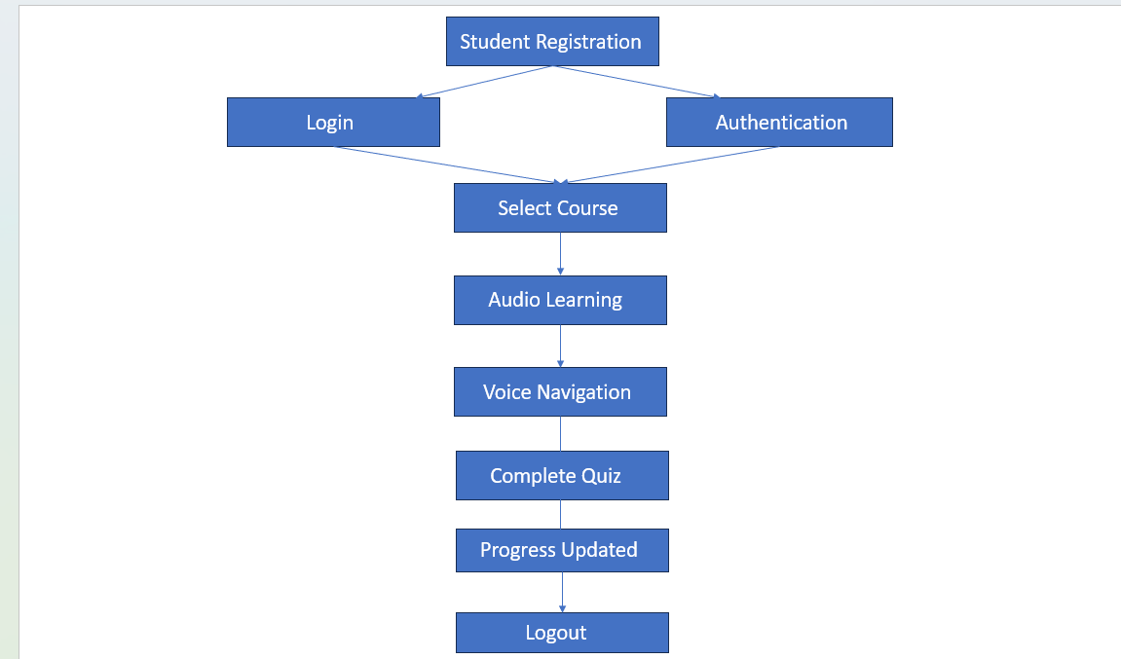

Use Case Diagram
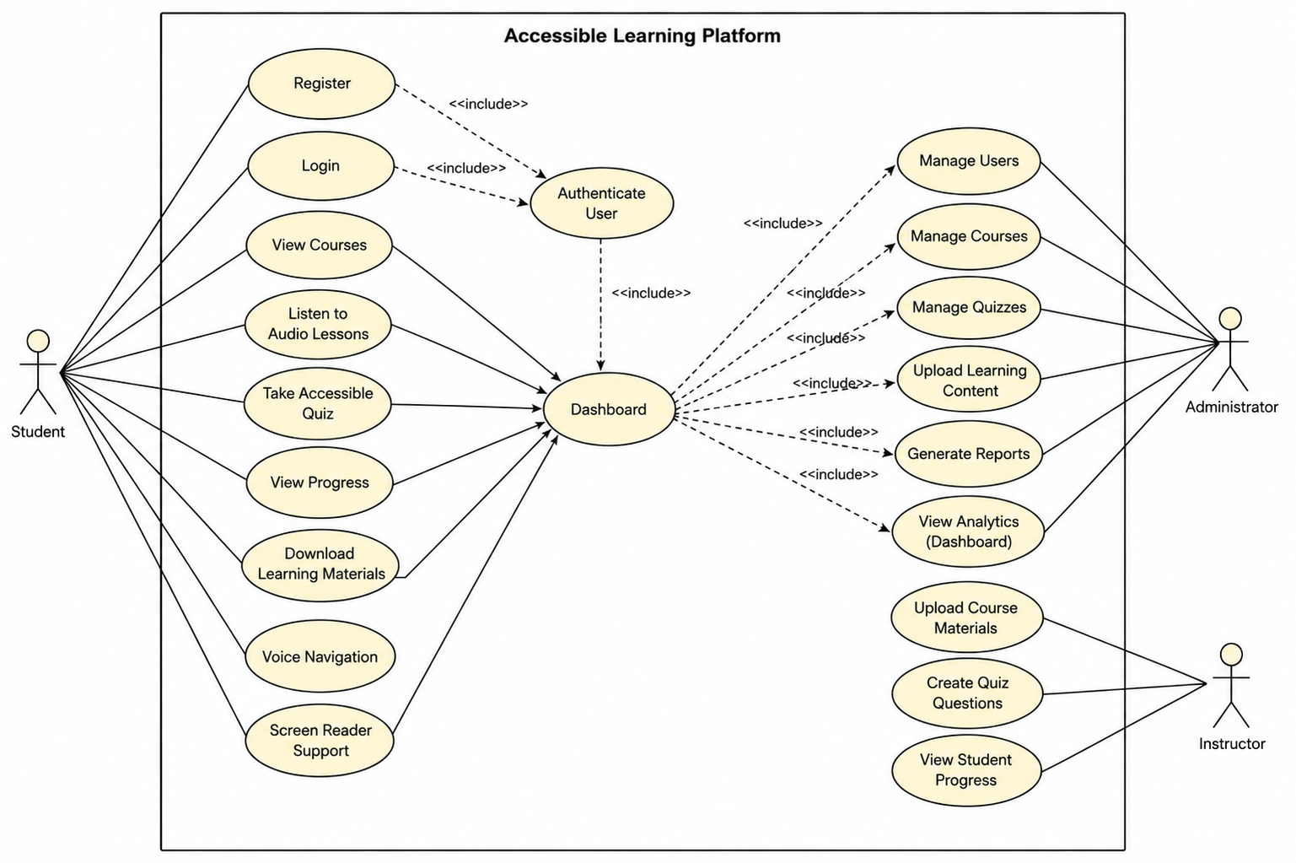

Activity Diagram
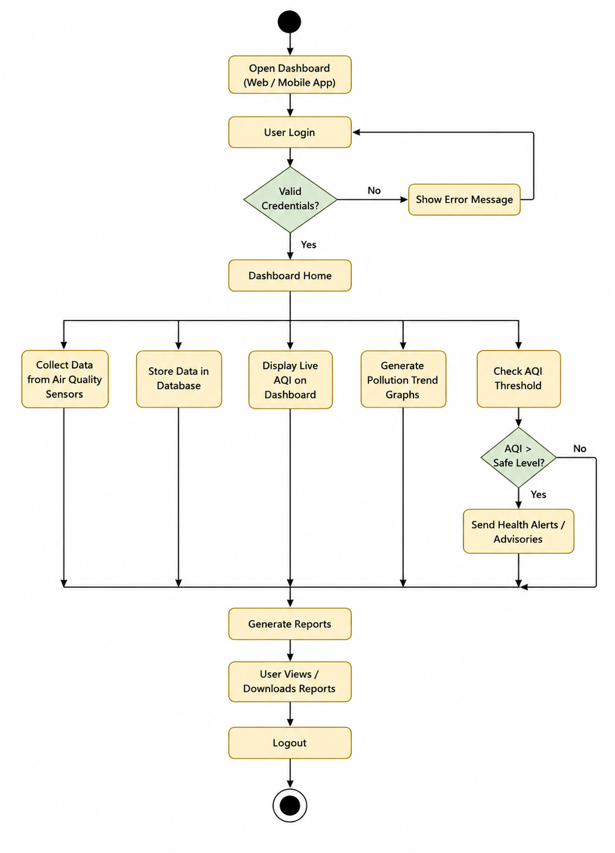
ER Diagram

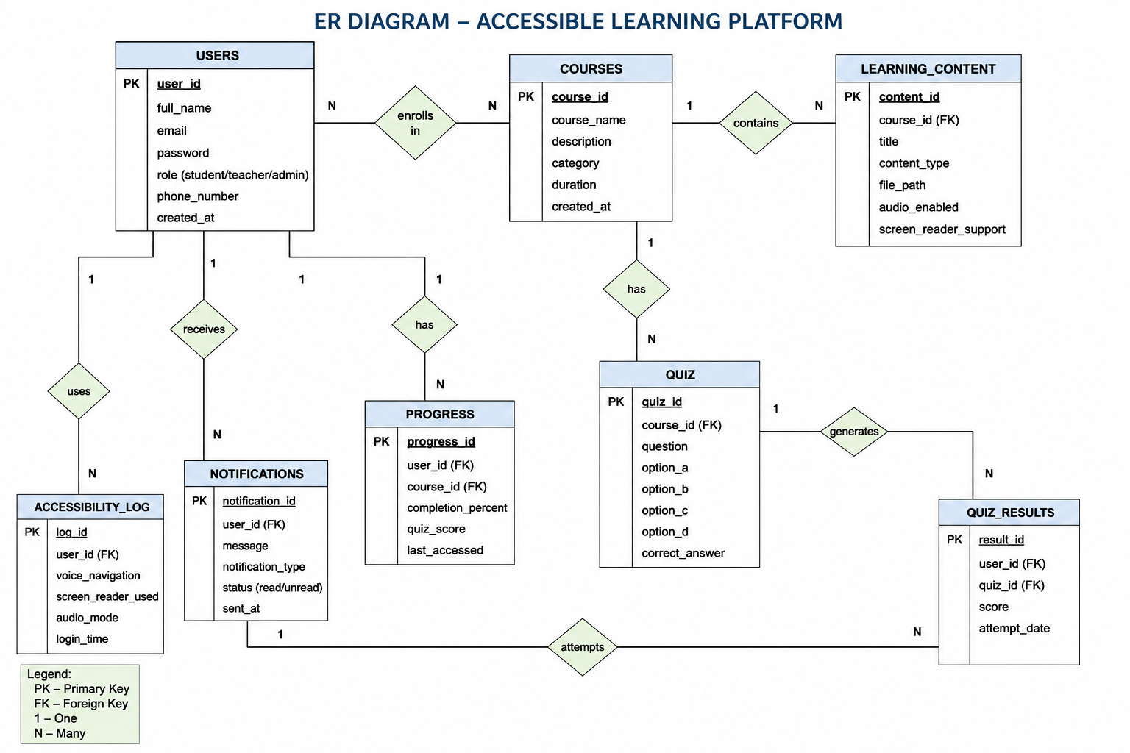
System Architecture
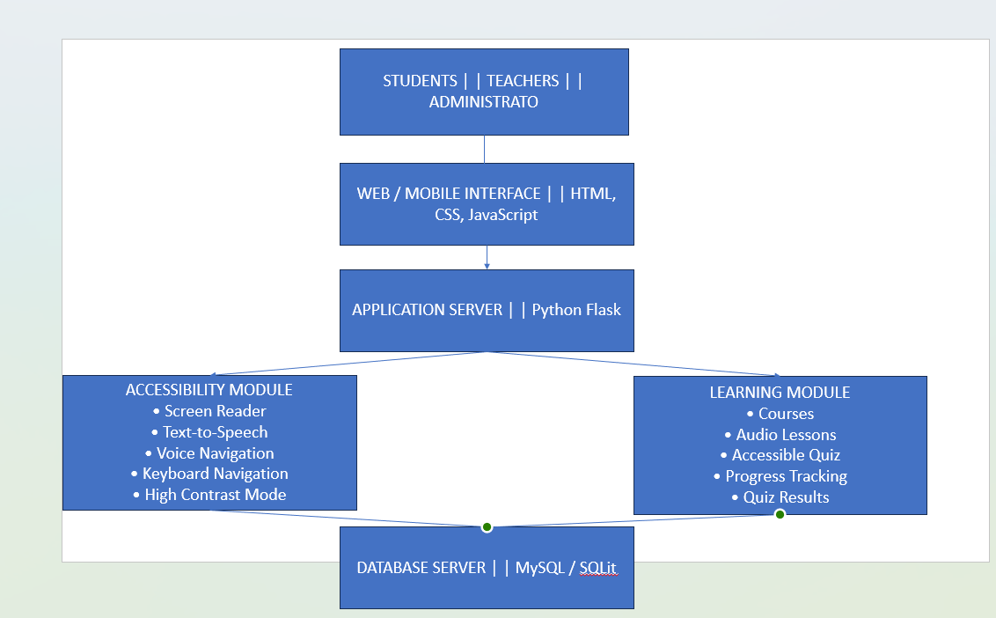

FLOWCHART

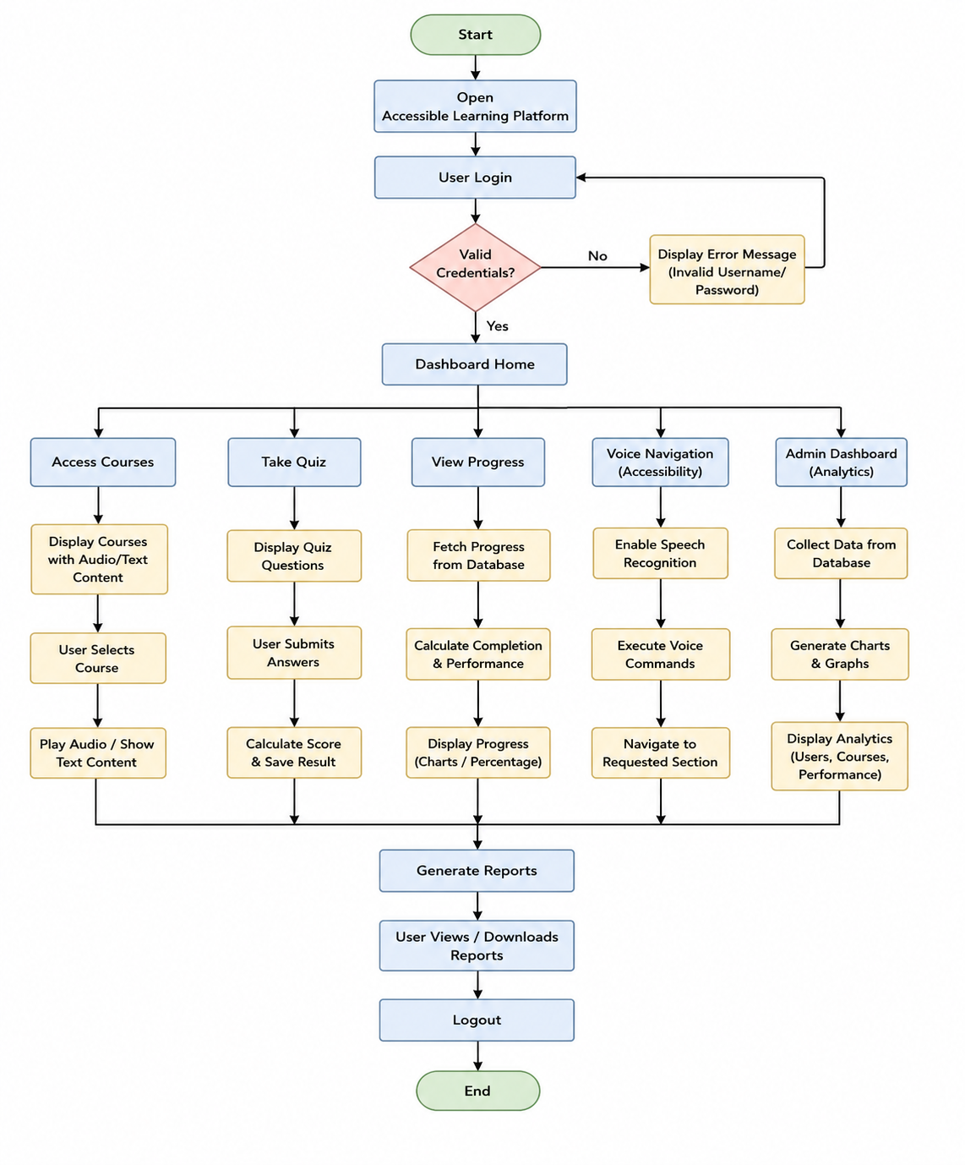

7. Methodology / SDLC Selection
Selected Model
Agile SDLC
Why Agile?
- Supports continuous improvement.
- Frequent testing.
- Easy to collect user feedback.
- Suitable for accessibility enhancements.
Advantages
- Faster development.
- Flexible changes.
- Better collaboration.
- Early delivery.
Development Stages
- Requirement Gathering
- Planning
- Design
- Development
- Testing
- Deployment
- Maintenance

8. Implementation Plan
Phase | Duration
Requirement Gathering | 1 Week
System Design | 1 Week
Development | 3 Weeks
Testing | 1 Week
Deployment | 1 Week
Maintenance | Continuous

9. Expected Outcomes
Benefits
- Inclusive education.
- Better accessibility.
- Improved academic performance.
- Independent learning.
Business Impact
- Increased student satisfaction.
- Better institutional reputation.
- Compliance with accessibility standards.
User Benefits
- Easy navigation.
- Accessible assessments.
- Audio learning resources.
- Voice interaction.
Social Impact
- Equal educational opportunities.
- Reduced digital divide.
- Improved quality of education.
SDG Contribution
Supports SDG 4: Quality Education by ensuring inclusive and equitable education for visually impaired students.

10. Risks and Limitations
- Internet dependency.
- Data privacy concerns.
- Cybersecurity threats.
- Budget constraints.
- User training requirements.
- Integration challenges.
- Device compatibility issues.

11. Future Enhancements
- AI-powered learning assistant.
- Chatbot support.
- Mobile application.
- Cloud deployment.
- Predictive learning analytics.
- Multi-language support.
- OCR for printed documents.
- Smart voice assistant integration.

12. Conclusion
The proposed Accessible Learning Platform provides an effective solution for addressing the accessibility challenges faced by visually impaired students in digital education. By integrating screen reader compatibility, voice navigation, audio learning resources, keyboard accessibility, and inclusive online assessments, the platform enables students to learn independently and confidently. The solution follows sound software engineering principles, adopts the Agile development methodology, and aligns with United Nations Sustainable Development Goal 4 (Quality Education) by promoting inclusive, equitable, and accessible learning opportunities for all.

13. References
- United Nations. Sustainable Development Goal 4: Quality Education. https://sdgs.un.org/goals/goal4
- World Wide Web Consortium (W3C). Web Content Accessibility Guidelines (WCAG) 2.2. https://www.w3.org/WAI/standards-guidelines/wcag/
- World Health Organization (WHO). World Report on Vision. https://www.who.int
- Pressman, R. S., & Maxim, B. R. Software Engineering: A Practitioner's Approach. McGraw-Hill.
- Sommerville, I. Software Engineering (10th Edition). Pearson.
- IEEE Xplore Digital Library. https://ieeexplore.ieee.org
- ACM Digital Library. https://dl.acm.org
- SpringerLink. https://link.springer.com
- UNESCO. Inclusive Education. https://www.unesco.org
- National Institute for the Empowerment of Persons with Visual Disabilities (India). https://nivh.gov.in

